# Chapter 1

Table of Contents

Chapter 1 1

Create First Worksheet 3

Import Data from Excel into Tableau. 3

Create Region Worksheet 7

Create Bar Chart 14

Create Pie Chart 16

# Create First Worksheet

## Import Data from Excel into Tableau.

Just a note before we begin, for importing or connecting data in Tableau using drivers – you may see an error and a request to download and install the drivers.

~~So~~ To import data from our template **Starter data.xlsx** go to the main Tableau screen, at section **Connect->To a File** and select the **Excel file.**



Create First Worksheet



Create Region Worksheet

Create Bar Chart

Create Pie Chart

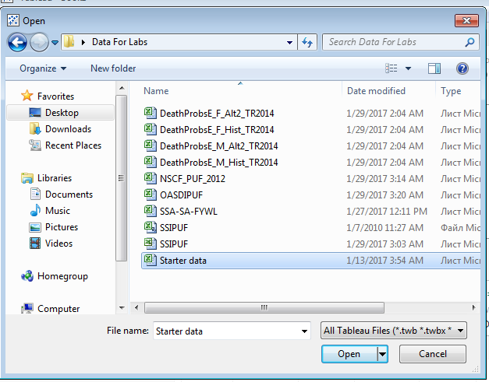

After loading your data, you will see the initial screen. Here - you can visually select the data, and **select conditions,** that will be used in the worksheets. In our example, we do not need to choose any filters, because we have pure data sources. We will come back to this step later.

We will select only **Output** table.

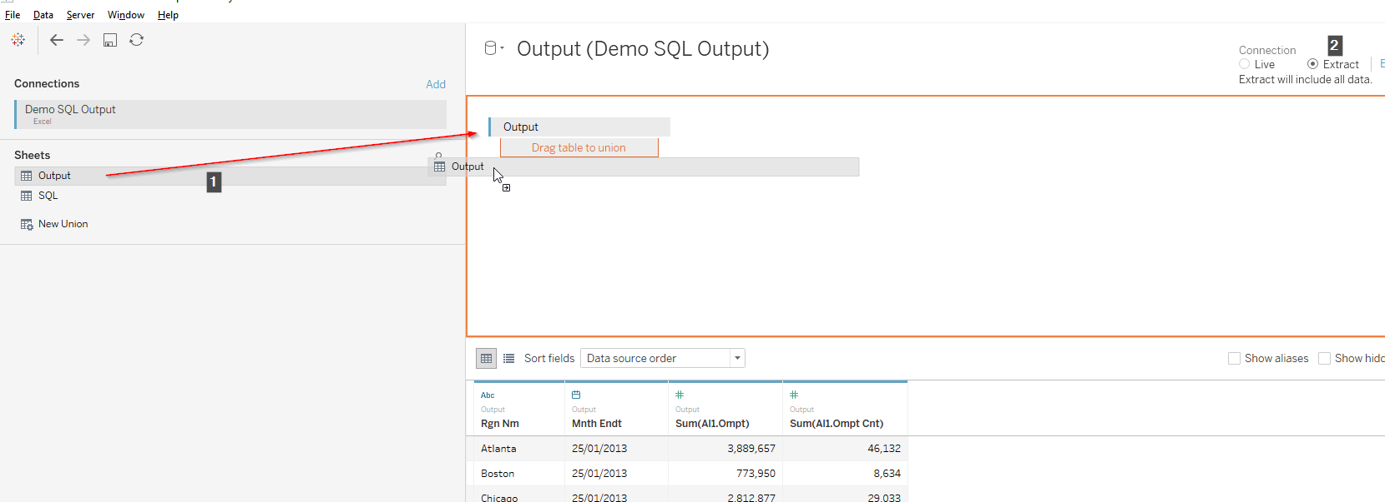

Tableau provide the possibility of showing data in next conditions:



Create First Worksheet



Create Region Worksheet

Create Bar Chart

Create Pie Chart

* **Live –** for databases that must be monitored in real time.
* **Extract –** for local databases, which will not be changed or databases where changes are not large.

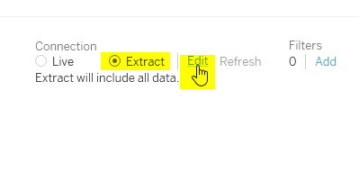

On the right, you will see additional filters - this is very useful for large data samples.

For our sample table, we do not need **Live** updates, so we will change for Extract. We do not need any additional filters in global to choose now.

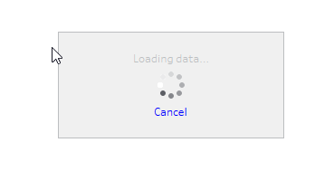

After end of data extraction, we can open our first worksheet. By default name of “Sheet 1”.



Create First Worksheet



Create Region Worksheet

Create Bar Chart

Create Pie Chart

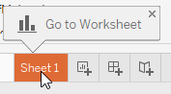

Create First Worksheet



Create Region Worksheet

Create Bar Chart

Create Pie Chart



## Create Region Worksheet

Here we will create main Worksheet page, where we will show data grouped by Region.

We should first create a few calculated fields. These preconditions can be useful in different **filters** or **type fields** for better customization at **Tableau**.

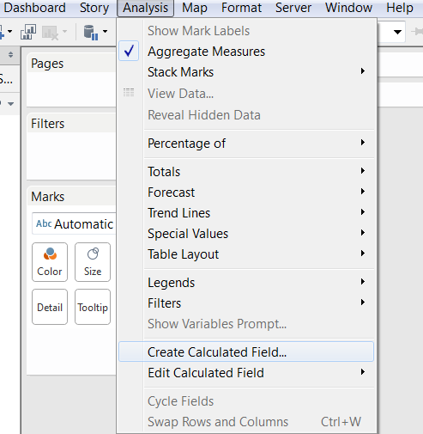

Let’s create a couple of calculated fields. We need to summarize **Ompt** and **Ompt Cnt.**  We will create an average by that and then sum the results.



Create First Worksheet



Create Region Worksheet

Create Bar Chart

Create Pie Chart



Newer versions of Tableau provides default “sum” for compatibly by type columns. You can also create them yourself as illustrated below.

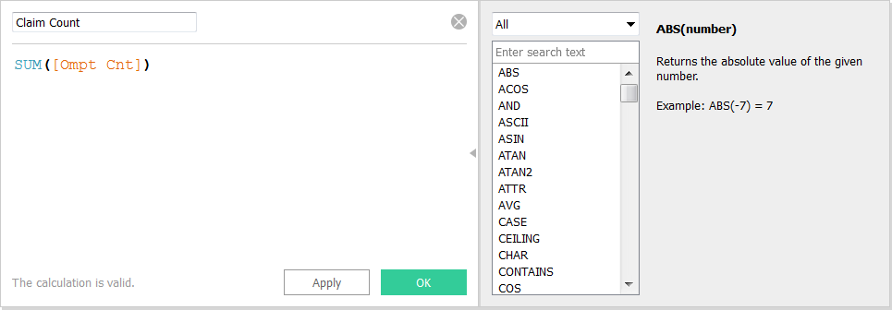

We will use predefined sums during creation of the Average.

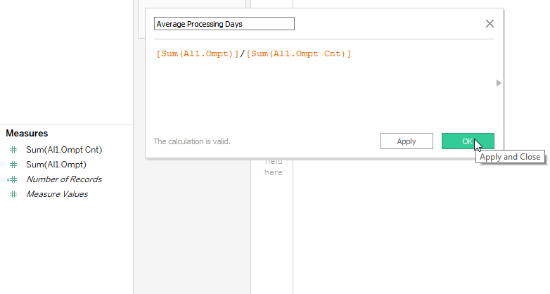

Create First Worksheet



Create Region Worksheet

Create Bar Chart

Create Pie Chart



At our Region Worksheet we will use recommended **Table View:**

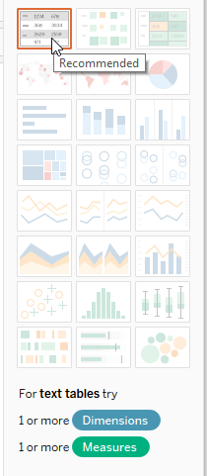

At **Sheet1 -** drag & drop **Mnth Endt dimension to columns** and **Rgn Nm dimension to rows** as illustrated in the screen grab below.

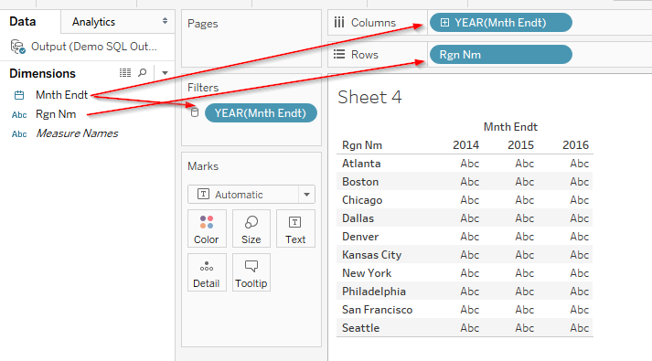

Create First Worksheet



Create Region Worksheet

Create Bar Chart

Create Pie Chart



Select **Show Filter** sub-option at **Year Filter** for create a customized range in the output dashboard.

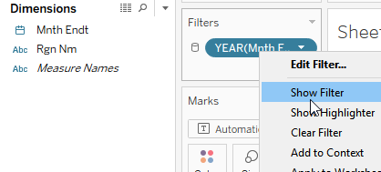

Now let’s provide more details in our result view.

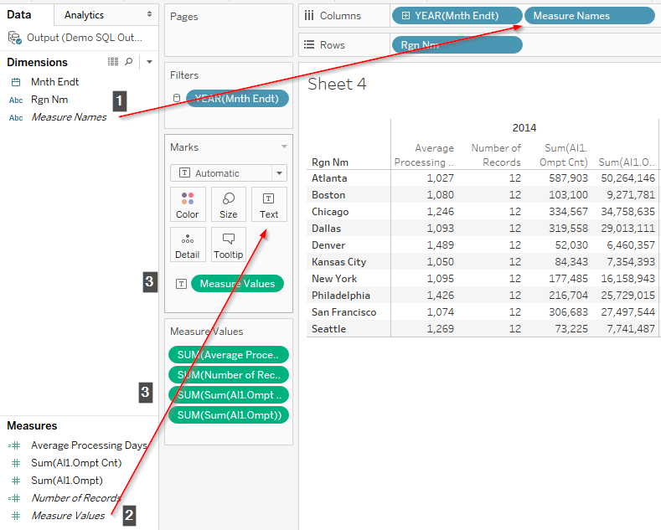

Create First Worksheet



Create Region Worksheet

Create Bar Chart

Create Pie Chart



**Here we have impact!**

Let us look deeply at all stages:

1. Drag & drop column **Measure Names** into **Columns** region.
2. Drag & drop predefined condition **Measure Values** into **Marks** region (we will use **Text).**
3. Now, all filters and values will be generated automatically.

Let’s end our page.

You can customize the name of the worksheet. Within the cell or for each part of the sheet, you can choose to customize special regions in the left panel or select manually from **Format Menu.**

You can see some of the options listed below:

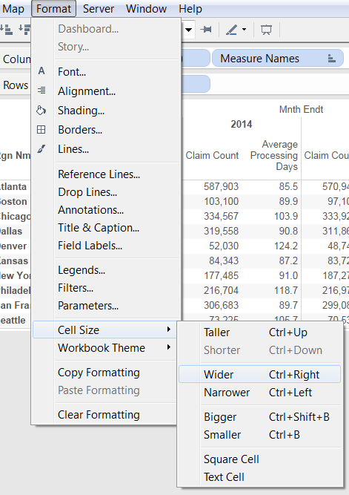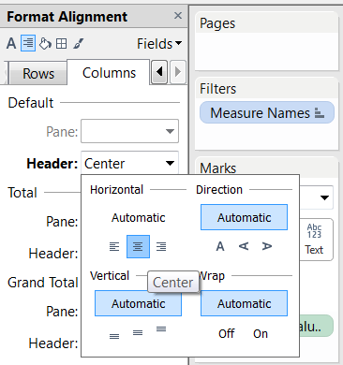



Create First Worksheet



Create Region Worksheet

Create Bar Chart

Create Pie Chart



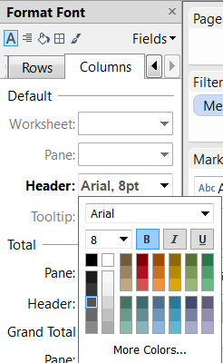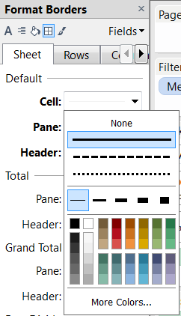



Create First Worksheet



Create Region Worksheet

Create Bar Chart

Create Pie Chart



Here is couple more important options:

1. Creation of total rows for couning views:

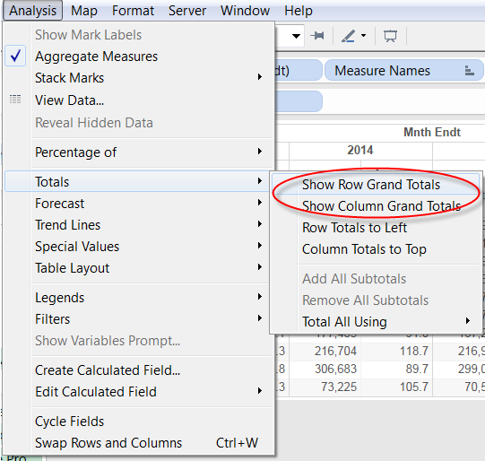



Create First Worksheet



Create Region Worksheet

Create Bar Chart

Create Pie Chart



1. Enable the title by selection “Show Title”:

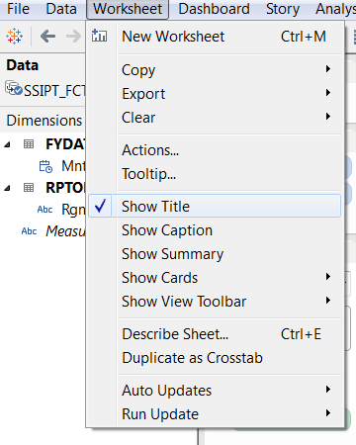

1. After double clicking you will get a modal window with the ability to edit it:

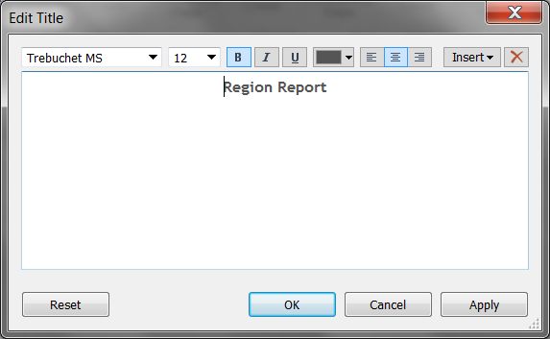

Your **Region Worksheet** worksheet is now completed.



Create First Worksheet



Create Region Worksheet

Create Bar Chart

Create Pie Chart



## Create Bar Chart

To create a new worksheet – you can use the buttons near the bottom of our current worksheet:

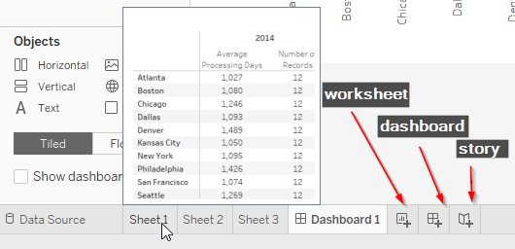

We will evaluate all buttons in future labs - here we will use only **“New Worksheet”** and **“New Dashboard”** buttons to create new result views and summarize them.



Create First Worksheet



Create Region Worksheet

Create Bar Chart

Create Pie Chart



At your new worksheet, you are to create **six** action to create a **Bar Result View.**

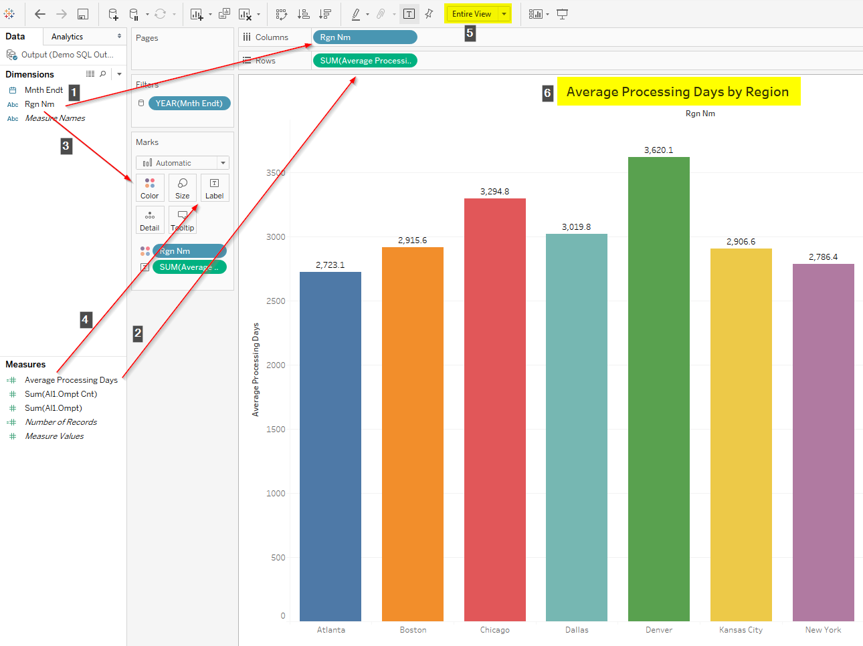

Let us look into each step:

1. Drag & drop **Rgn Nm** column into **Columns** region.
2. Drag & drop **Average Processing Days** field into **Rows** region.
3. Drag & drop **Rgn Nm** column into **Marks** especially at **Color** section.
4. Drag & drop **Average Processing Days** field into **Marks** especially at **Label** section.
5. Change default view into **Entire View.**
6. Change default name of worksheet.

This is all that is needed to create colored bars in your bar chart with average labels included.



Create First Worksheet



Create Region Worksheet

Create Bar Chart

Create Pie Chart



## Create Pie Chart

Creation of Pie Chart is similar to creating a Bar Chart.

We can duplicate steps 1-4 of the previous paragraph or simply duplicate the worksheet:

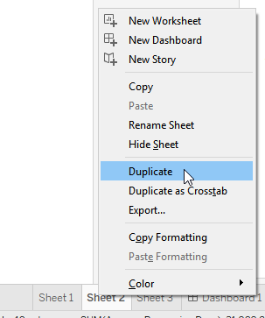

The next step is to convert result view from **Bar** into **Pie:**

і

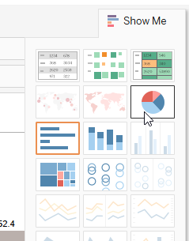

Create First Worksheet



Create Region Worksheet

Create Bar Chart

Create Pie Chart



Now we should drag & drop **Rgn Nm** column and **Average Processing Days** field into **Marks** at the **Label** section:

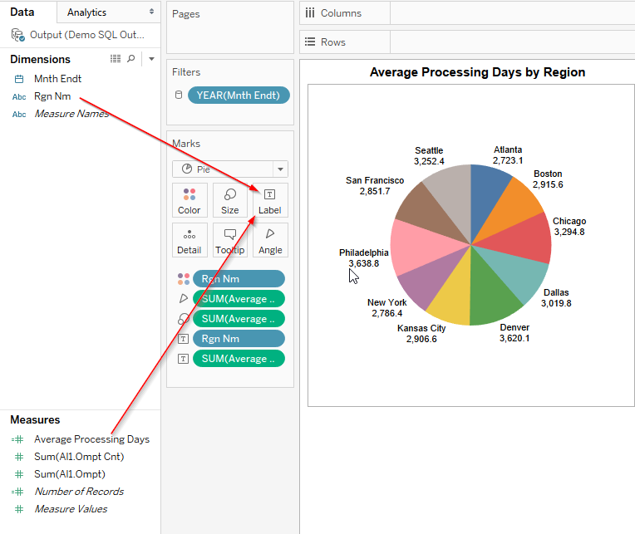

**Queue is not affect here.**

## Creation of new Dashboard



Create First Worksheet



Create Region Worksheet

Create Bar Chart

Create Pie Chart



Let’s add new **Dashboard** by clicking at “**New dashboard**” button at footer menu. After creation you will see empty dashboard with default name “**Dashboard #**”, where # is next number equal to count of dashboards at current **Tableau Book.**

Dashboard have 6 important sections. Two of them will be reviewed later.

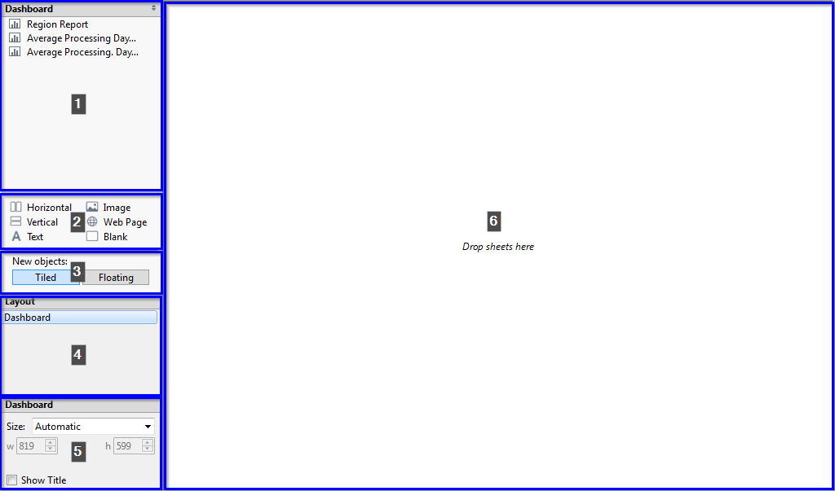

Sections from **1** to **5** need to define the resulted view of dashboard, here we can define size and format of dashboard**(5),** changing type of dropped objects**(3)** and drop created worksheets**(1)** or different objects**(2)** into resulting dashboard view**(6)**.

Make sure that at section **3** select type is **Tiled**, and move all worksheets inside resulting view**(6)**.



Create First Worksheet



Create Region Worksheet

Create Bar Chart

Create Pie Chart

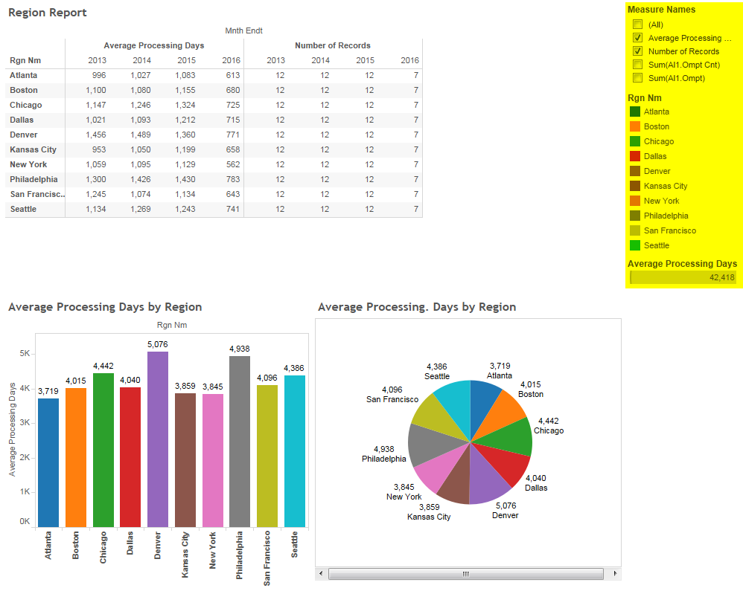

In the right panel, you have filters from all sheets - if you need to make it global just select the proper option:

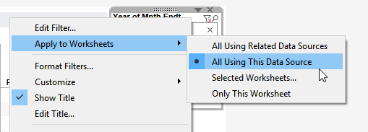

## Let's summarize our lesson:



Create First Worksheet



Create Region Worksheet

Create Bar Chart

Create Pie Chart



* We learned how to get data from tables and to build on them graphics.
* Learned the basics of creating custom fields.
* Learned how to convert and change table for bars and pies.
* Briefly review the possibility of definitions of dashboards.